**PROGRAM – 9**

**AIM**: Write a program to find page fault for a given string of pages(size 20). Assume the memory frames is an array of size n. Use FIFO algorithm with counters or stack. What is the effect of increasing the number of memory frames?

**INTRODUCTION**: A page fault occurs when a program attemts to access data or code that is in its address space, but is not currently located in the system RAM. In the following program we use the FIFO page replacement algo to find out the number of hits and misses. In this algorith, operating system keeps track of all the pages in the memory in a queue, oldest page is in the front of the queue. When a page needs to be replaced page in the front of the queue is selected for removal.

**C PROGRAM :**

#include <bits/stdc++.h>

using namespace std;

int searchvector(vector<int> v,int item){

for (int i = 0; i < v.size(); ++i){

if (item == v[i]){

return 1;

}

}

return 0;

}

int main(){

int n,hits=0,miss=0;

//int pages[20] = {7,0,1,2,0,3,0,4,2,3,0,3,2,1,2,0,1,7,0,1};

//int pages[12] = {5,4,3,2,5,4,6,5,4,3,2,6};

int p_no;

cout<<"\nEnter no. pages : ";

cin>>p_no;

int pages[p_no];

cout<<"\nEnter string containing Pages : ";

for (int i = 0; i < p_no; ++i){

cin>>pages[p_no];

}

cout<<"\nEnter no. of memory frames: ";

cin>>n;

vector<int> cache;

int p;

for (int i = 0; i < p_no; ++i){

p = pages[i];

if (searchvector(cache,p)){

hits++;

}else{

if (cache.size() >= n){

cache.erase(cache.begin());

}

cache.push_back(p);

miss++;

}

}

cout<<"\nhits = "<<hits;

cout<<"\nmiss = "<<miss<<endl;

return 0;

}

**OUTPUT:**

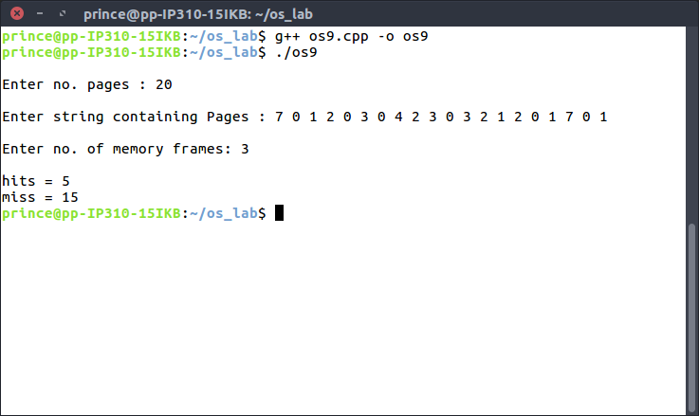

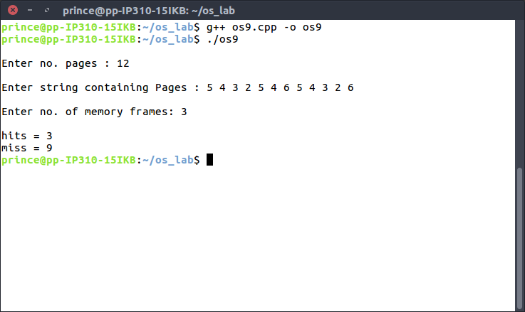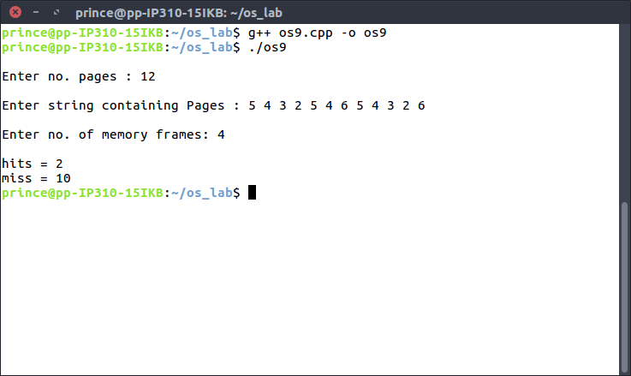

**LEARNING OUTCOMES:** From this program, we learnt the concept of Page Faults and how through the FIFO page replacement algorithm, we can measure the number of Page Faults. Also, we observe that on increasing the number of frames, the number of page faults increase. This can be attributed to the Belady’s Anomaly.